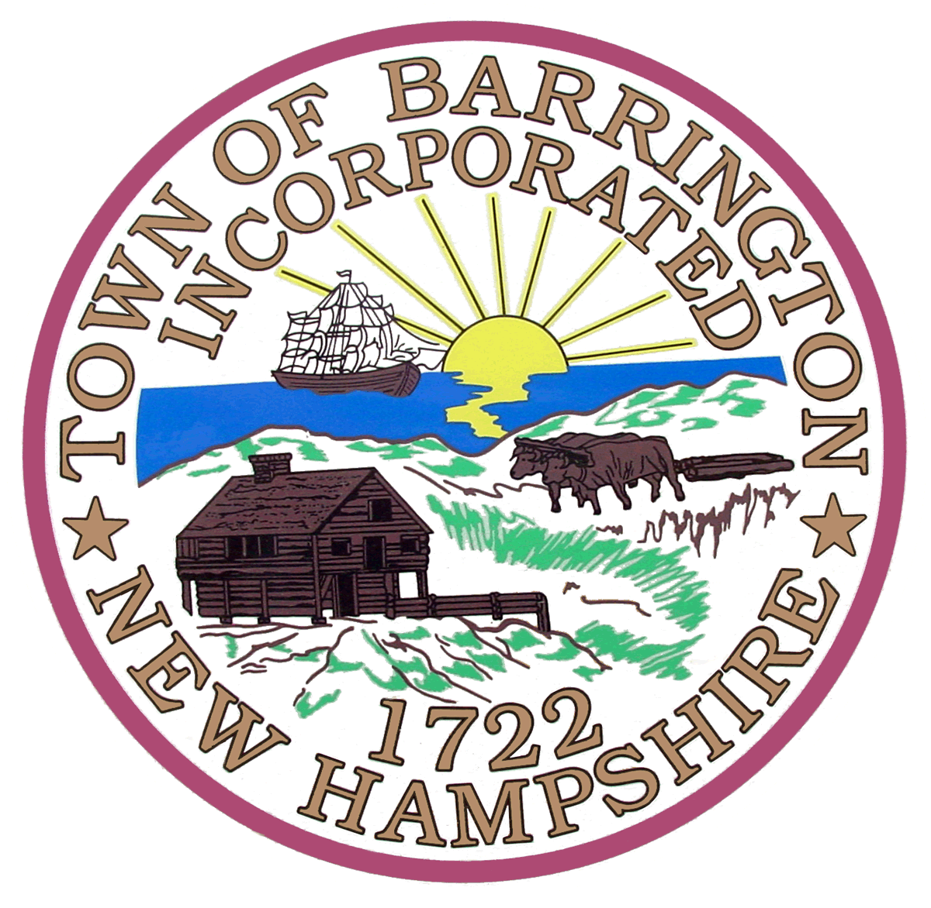 Town Clerk’s Office
PO BOX 660
Barrington, NH 03825

I, ______________________________________________, do certify that

____________________________________, DOB: __________________

resides at the following address:_________________________________

in Barrington, NH 03825 and has since___________________________.

Signature: __________________________________ Date: ___________
Printed name: _______________________________

Signature: __________________________________ Date: ___________
Printed name: _______________________________

Signed under penalty of law---NH State Statutes 641:1 and 641:3.

Daytime Phone Number: _______________________________

RSA 641:1 Perjury. –
I. A person is guilty of a class B felony if in any official proceeding:
(a) He makes a false material statement under oath or affirmation, or swears or affirms the truth of a material statement
previously made, and he does not believe the statement to be true; or
(b) He makes inconsistent material statements under oath or affirmation, both within the period of limitations, one of which is
false and not believed by him to be true. In a prosecution under this section, it need not be alleged or proved which of the
statements is false but only that one or the other was false and not believed by the defendant to be true.
II. "Official proceeding" means any proceeding before a legislative, judicial, administrative or other governmental body or
official authorized by law to take evidence under oath or affirmation including a notary or other person taking evidence in
connection with any such proceeding. "Material" means capable of affecting the course or outcome of the proceeding. A
statement is not material if it is retracted in the course of the official proceeding in which it was made before it became manifest
that the falsification was or would be exposed and before it substantially affected the proceeding. Whether a statement is material
is a question of law to be determined by the court.
RSA 641:3 Unsworn Falsification. – A person is guilty of a misdemeanor if:
I. He or she makes a written or electronic false statement which he or she does not believe to be true, on or pursuant to a form
bearing a notification authorized by law to the effect that false statements made therein are punishable; or
II. With a purpose to deceive a public servant in the performance of his or her official function, he or she:
(a) Makes any written or electronic false statement which he or she does not believe to be true; or
(b) Knowingly creates a false impression in a written application for any pecuniary or other benefit by omitting information
necessary to prevent statements therein from being misleading; or
(c) Submits or invites reliance on any writing which he or she knows to be lacking in authenticity; or
(d) Submits or invites reliance on any sample, specimen, map, boundary mark, or other object which he or she knows to be false.
III. No person shall be guilty under this section if he or she retracts the falsification before it becomes manifest that the
falsification was or would be exposed.

