[Online ServicesOnline Services](https://www.nh.gov/safety/divisions/dmv/online-services/index.htm)

Top of Form

Bottom of Form

[Online Services](https://www.nh.gov/safety/divisions/dmv/online-services/index.htm)

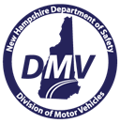Top of Form

Bottom of Form

Top of Form

Bottom of Form